Determine Monthly Status
Today the date is: 03-06-2026 (03 June 2026), so current month = June 2026
Nifty spot current index = 23483.55
The chart below is monthly timeframe Nifty50 chart.
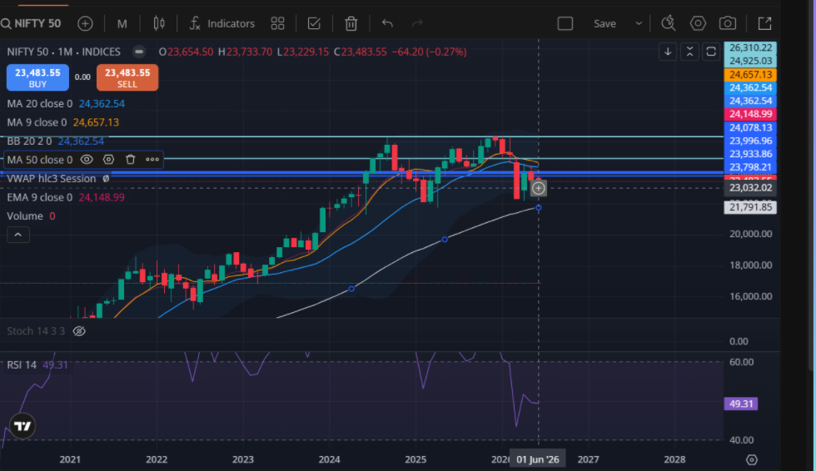
Prev Month will be May 2026
Prev Month Low (PML) = 23262.55,
Prev Month High (PMH) = 24482.10

Current month Low (CML) = 23229.15
Current month high (CMH) = 23733.70

Nifty CML < PML, so this month price breached below PML, calculate Bearish Value = PML - 0.75% = 23262.55 - 23262.55*0.75% = 23088.08
So the price did not go below PML. Also CMH did not breach PMH, so monthly status remains UNKNOWN and it will be borrowed from the monthly status of previous month.

Nifty Current spot also is between PMH and PML, so monthly status cannot be determined based on previous month high and low and hence we will take the current monthly status as unknown and its monthly status will be borrowed from the monthly status of the previous month means May 2026. But we do not know the monthly status of May 2026 and to find this we need to compare the high and low of May month with that of previous month means April month. Thus, May will be treated like current month and April will be taken as Previous month.

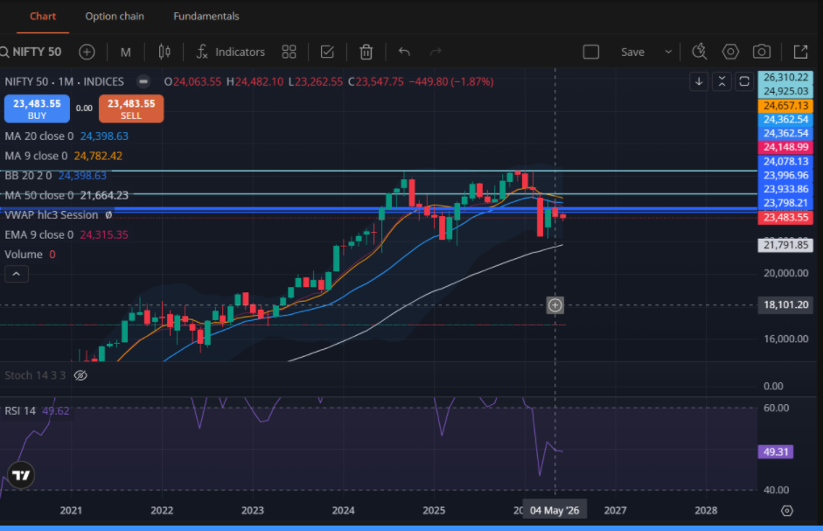

Thus current month = May,
CMH = Current Month High = May month high = 24482.10
CML = Current Month Low = May month low = 23262.55

Prev Month = April
As we can see on the chart below for April month, we have:
Prev Month Low (PML) = April Month Low = 22182.55
Prev Month High (PMH) = April Month High = 24601.70

As we can see May Month high < April Month High and May month Low > April Month Low.
Means CMH < PMH and CML > PML, so monthly status of May is unknown and it will be borrowed from the monthly status of April.

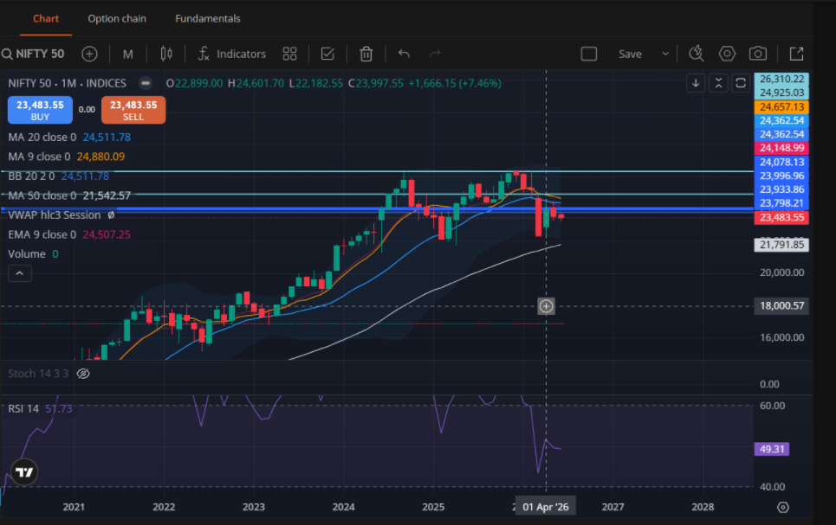

To calculate the monthly status of April 2026, we would need the monthly status of March which we can see below:
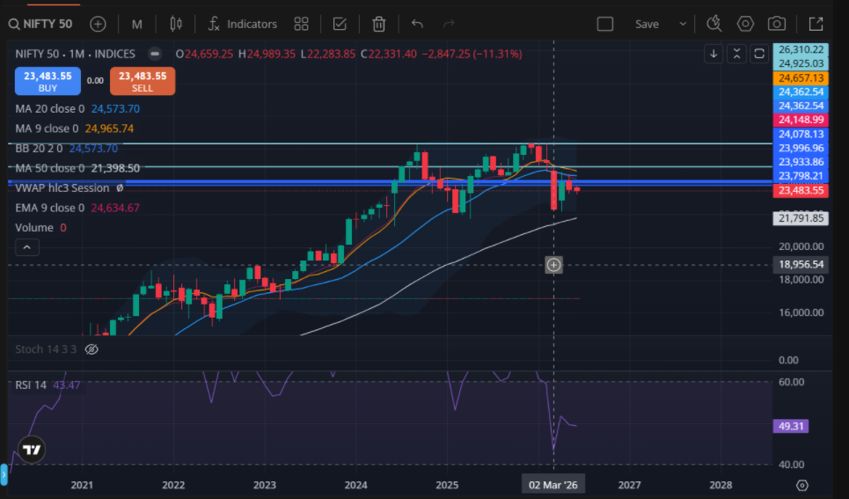

April becomes current month, while March becomes Previous month,

CML = Current Month Low = April month low = 22182.55
CMH = Current Month High = April month high = 24601.70

Prev Month Low (PML) = March Month Low = 22283.85
Prev Month High (PMH) = March Month High = 24989.35

This time CMH < PMH but CML < PML means price went below PML but by how much? Did the price go down by >= 0.75% ?
Why 0.75%? Because for nifty and bank nifty a = 0.75%

PML - 0.75% = -0.75% = 22283.85 = 22283.85 - 0.75% of 22283.85 = 22115.87
IS CML < 22115.87? CML = 22182.55 which is not less than 22115.87, so monthly status of April remains unknown and will be borrowed from Monthly status of March 2026.

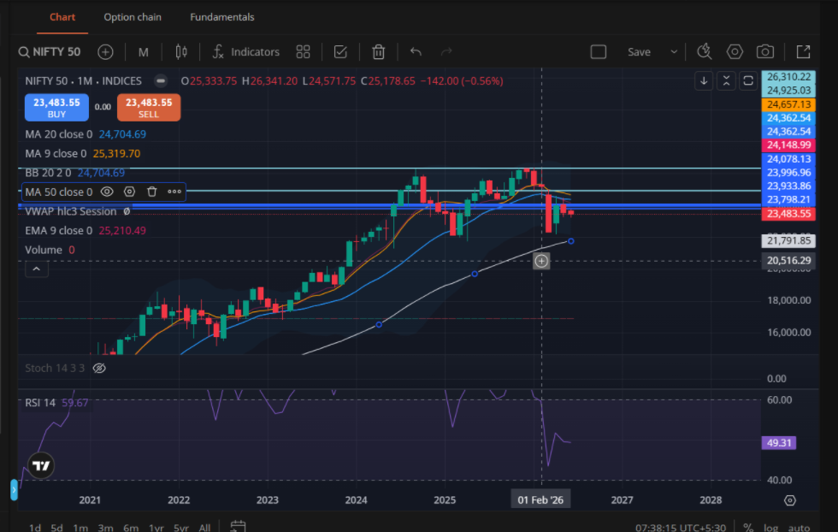

Now let us calculate the monthly status of March 2026.
Current month = March 2026,
Prev month = Feb 2026

CML = Current Month Low = March month low = 22283.85
CMH = Current Month High = March month high = 24989.35

Prev Month Low (PML) = Feb Month Low = 24571.75
Prev Month High (PMH) = Feb Month High = 26341.20

CML < PML and CMH < PMH, so current month low breached the PML, we need to get the values calculated.

Bearish Value = PML -0.75 % = 24571.75 - 0.75% * 24571 = 24387.46
CML = 22283.85 < Bearish Value, so we conclude that March month is Bearish
Monthly status o March 2026 = 2026 Bearish

But we also need to check if it is bearish confirmed as well.
Bearish Value - 0.75 % = 24387.46 - 24387.46*0.75% = 24204.55

CML = 22283.85 < Bearish value - 0.75 % which is 24204.55,
So, monthly status of March 2026 is Bullish Confirmed.

Now we do not need to go further back because this is the monthly status of June as well till today. Why? Because June month borrowed Maay month status which borrowed April Month Status which borrowed March month Status but March month status is clearly Bearish confirmed and hence June month status is bearish confirmed.

Now as of 03 June 2026 the monthly status is BEARISH CONFIRMED, so we will note this down that current monthly status = BEARISH CONFIRMED and
Every day when we calculate monthly status, we will not run the whole calculation above, rather we will check if today's price has given any reversal or not based on the formula below:

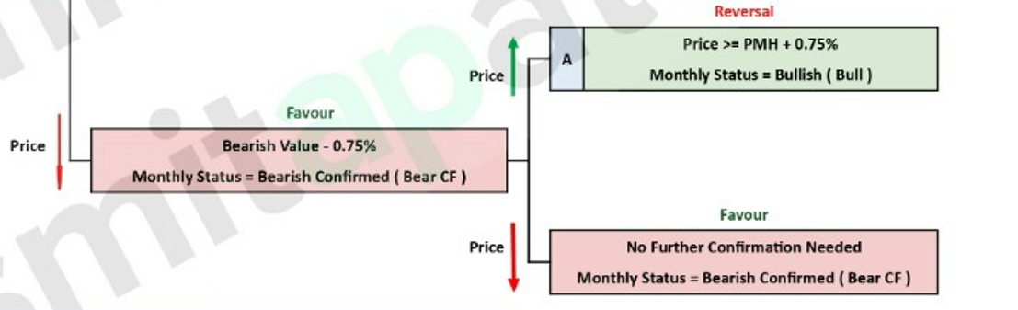

As we are in Bearish Confirmed Monthly Status, now if the current price goes up by 0.75% of PMH (means May Month High), only that will change the monthly status to Bullish only (not bullish confirmed) otherwise the monthly status remains the borrowed month status which is bearish confirmed.

More clarification:

The rules are straightforward. If currently determined monthly status is BEARISH (Not bearish confirmed) and price goes up, then we calculate Previous Week High (PWH) and Current Week High(CWH). If current price is 0.15% more than the max (PWH, CWH), we change the monthly status to BULLISH
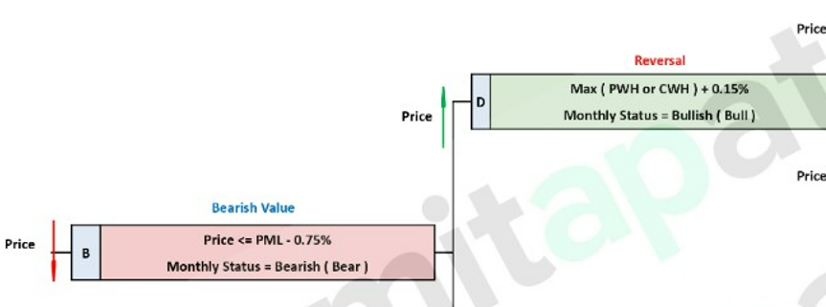

If monthly status is BULLISH, then BULLISH VALUE is = PMH + 0.75%
Now if Price >= BULLISH VALUE + 0.75%, we declare monthly status to be BULLISH CONFIRMED.

If we are in BULLISH CONFIRMED and price goes up, status remains BULLISH CONFIRMED but if price < PML -0.75%, then monthly Status = BEARISH

If monthly Status is BULLISH, and price reverses by 0.15% of min(PWL, CWL), we declare the monthly status to be bearish.

So if monthly status is bearish and current price <= min(PWL, CWL)-0.15%, monthly status = BEARISH as we can see here:

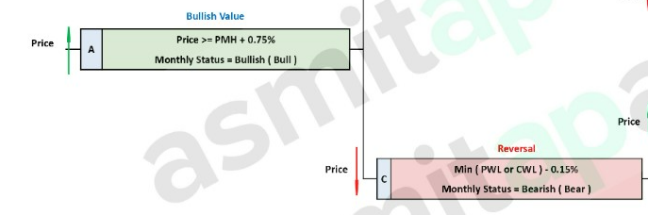

Thus the whole logic is explained in one place when our current monthly status is BULLISH.
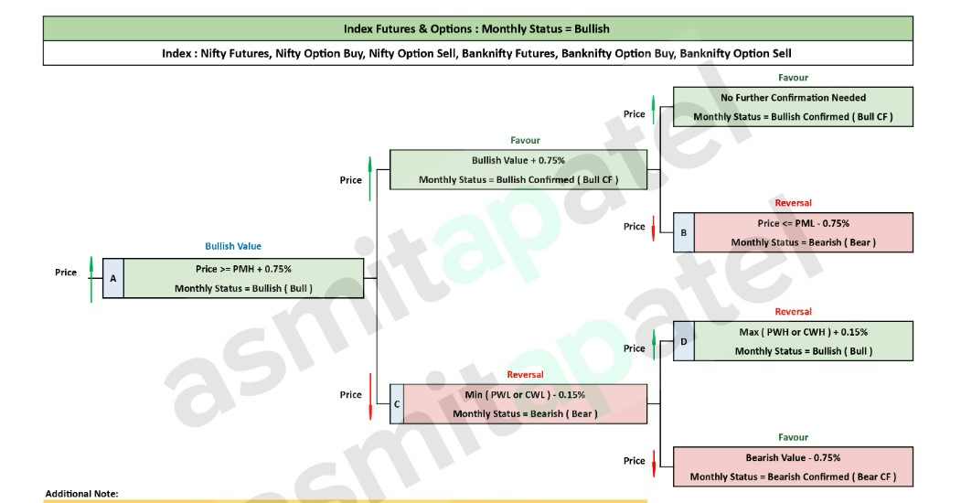

Similarly when our current monthly status is Bearish, the whole logic is shown below:
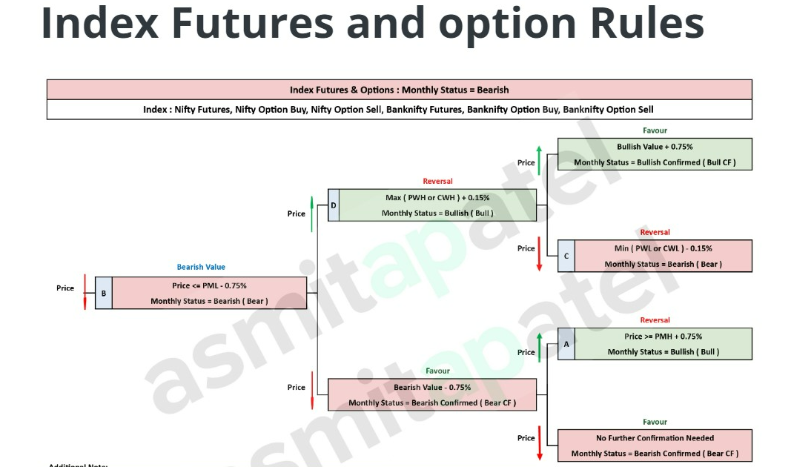

I hope now you should be clear on how we calculate the monthly status. Please confirm.

